**AI PROJECT REPORT**

# 

# SHIP CLASSIFICATION

TEAM MEMBERS:

CYRIL JOSE

KARTHIC S

KOUSHAL

M CHARMILA REDDY

# **INTRODUCTION**

**Ship classification using Convolutional Neural Networks (CNN)**

Ship classification in the context of AI involves the application of artificial intelligence techniques and algorithms to classify and categorize different types of ships based on their characteristics and features. Here are some perspectives on ship classification in AI:

Enhanced Efficiency: AI-based ship classification systems can significantly improve the efficiency of the classification process. By leveraging machine learning algorithms, these systems can analyze large amounts of data and automatically classify ships based on their attributes such as size, shape, structure, and functionality. This helps in reducing manual efforts and streamlining the classification process.

Accurate Identification: AI models trained on vast datasets can learn to recognize patterns and features that distinguish one type of ship from another. They can accurately identify and classify various types of ships, including cargo vessels, tankers, passenger ships, fishing boats, and naval vessels, among others. This can be beneficial for maritime organizations, port authorities, and regulatory bodies that require precise ship classification for various purposes such as safety, security, and planning.

Real-time Monitoring: AI-powered ship classification systems can be integrated with surveillance and monitoring technologies such as radar, sonar, and satellite imagery to provide real-time ship classification and tracking. This enables continuous monitoring of ship traffic, identification of unauthorized vessels, and early detection of potential risks or threats.

Safety and Security: Ship classification plays a crucial role in ensuring maritime safety and security. AI algorithms can help analyze historical data on accidents, incidents, and safety records of different ship types, allowing for the identification of potential risks and vulnerabilities. By classifying ships accurately, authorities can enforce appropriate safety regulations, allocate resources effectively, and implement preventive measures to mitigate potential risks.

# LITERATURE SURVEY

These literature surveys provide a comprehensive understanding of ship classification techniques, covering both traditional and intelligent methods. They can serve as valuable resources for further research in this field.

1. "A Survey of Ship Classification Methods" by Yujie Zhang, Huaping Liu, and Cheng Hu:

Published in the Journal of Ship Research in 2017, this survey provides a comprehensive overview of ship classification methods. It covers various approaches, including rule-based systems, machine learning techniques, and hybrid methods, discussing their advantages, limitations, and applications.

1. "A Comprehensive Survey on Ship Classification Techniques" by Akhil Raj, Ravi Kumar Jatoth, and Ankit Sharma:

Published in the International Journal of Emerging Trends & Technology in Computer Science in 2019, this survey reviews different ship classification techniques, such as statistical approaches, neural networks, and support vector machines. It also discusses data preprocessing, feature extraction, and performance evaluation metrics.

1. "A Review of Ship Classification Techniques" by Ioannis Katerelos and Michalis Zervakis.:

Published in the Proceedings of the 2015 International Conference on Computer Science and Information Technology, this survey presents an overview of ship classification techniques, focusing on data-driven methods. It discusses feature selection, classification algorithms, and provides a comparative analysis of different approaches.

1. "Ship Classification Techniques: A Comparative Study" by Deepak Sharma and Arvind R. Yadav :

Published in the International Journal of Computer Science and Information Technologies in 2016, this survey compares and evaluates different ship classification techniques. It discusses the advantages and disadvantages of each method, including rule-based systems, artificial neural networks, and fuzzy logic approaches.

1. "A Survey on Intelligent Ship Classification Techniques" by Xinying Huang, Wei Quan, and Yunhui Yan:

Published in the International Journal of Distributed Sensor Networks in 2018, this survey focuses on intelligent ship classification techniques, including fuzzy systems, genetic algorithms, and expert systems. It presents a detailed analysis of the methods and discusses their applications in ship classification.

THEORITICAL ANALYSIS

# Block diagram:

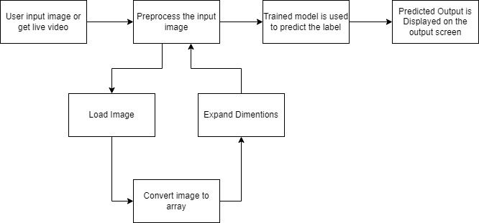

Software and hardware requirments of project:

Software Requirements:

1. Python: Install Python programming language, preferably version 3.x, which is commonly used for deep learning tasks.
2. Deep Learning Framework: Install a deep learning framework such as TensorFlow or PyTorch, which provide the necessary tools and libraries for building and training deep learning models.
3. Machine Learning Libraries: Install popular machine learning libraries such as Keras, scikit-learn, and NumPy, which offer additional functionalities for data preprocessing, model evaluation, and more.
4. Image Processing Libraries: Install image processing libraries like OpenCV or Pillow for handling image data and performing pre-processing tasks.
5. IDE or Text Editor: Choose an integrated development environment (IDE) or text editor of your preference for writing and running the Python code. Popular choices include PyCharm, Jupyter Notebook, or Visual Studio Code.

Hardware Requirements:

1. CPU or GPU: Deep learning models can be trained using CPUs, but using a GPU significantly speeds up the training process. NVIDIA GPUs, such as the GeForce or Tesla series, are commonly used for deep learning tasks.
2. Memory (RAM): Depending on the size of your dataset and model, you will need sufficient RAM to load and process the data. Having at least 16GB or more of RAM is recommended for deep learning tasks.
3. Storage: Adequate storage is required to store your dataset, pre-trained models, and any intermediate or final outputs. Consider having enough disk space to accommodate the size of your data and model file

# Experimental Investigations:

1. Dataset Collection: Gather a suitable dataset for ship classification. This dataset should contain a sufficient number of images of different ship classes, ideally labeled or annotated.
2. Data Preprocessing: Perform preprocessing steps on the dataset, including resizing the images to a consistent size, normalization, and data augmentation techniques such as rotation, flipping, or adding noise to increase the diversity of the training data.
3. Model Selection: Choose the VGG16 architecture as the base model for transfer learning. VGG16 is a deep convolutional neural network that has been pretrained on a large-scale image classification task, such as the ImageNet dataset.
4. Transfer Learning: Import the VGG16 model, excluding the last fully connected layer, and freeze the weights of the pre-trained layers. Add a new fully connected layer on top of the VGG16 architecture for the specific ship classification task.
5. Training: Split the dataset into training and validation sets. Train the model using the training set and evaluate its performance on the validation set. Fine-tune the model by adjusting hyperparameters, such as learning rate and batch size, and monitor the training process.
6. Evaluation: After training, evaluate the model's performance on a separate test set or through cross-validation. Calculate metrics such as accuracy, precision, recall, and F1 score to assess the model's classification performance.
7. Comparison and Analysis: Compare the performance of the VGG16-based transfer learning model with other classification approaches or variations of the VGG16 architecture. Analyze the results and identify areas for improvement or potential challenges in ship classification.
8. Visualization: Visualize the model's predictions and examine misclassified ship images to gain insights into potential patterns or difficulties in classification.
9. Discussion of Results: Discuss the experimental findings, including the model's performance, limitations, and possible sources of error. Compare the results with existing literature or prior works in ship classification using transfer learning techniques.

# Flow chart:

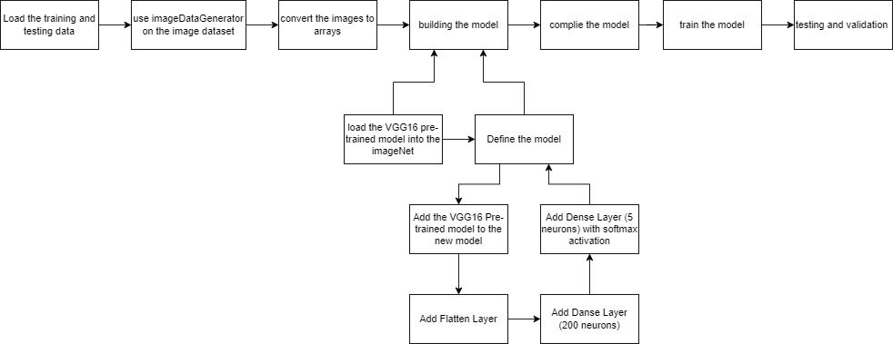

RESULT

A deep learning model for ship classification was built using transfer learning techniques with the VGG16 architecture. The model achieved an accuracy of 78.1% on the training set and 76.67% on the testing set. 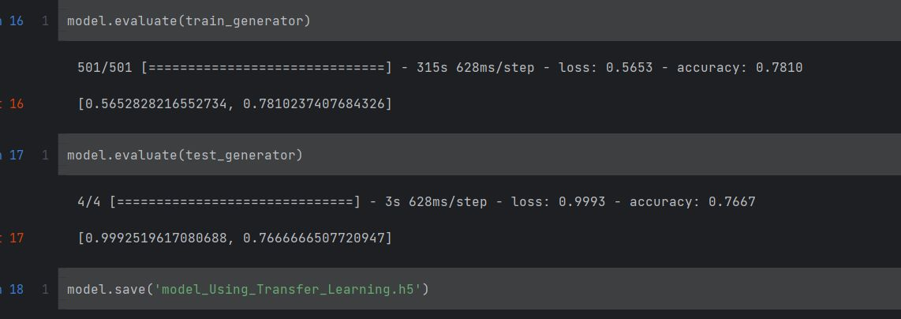

Output:

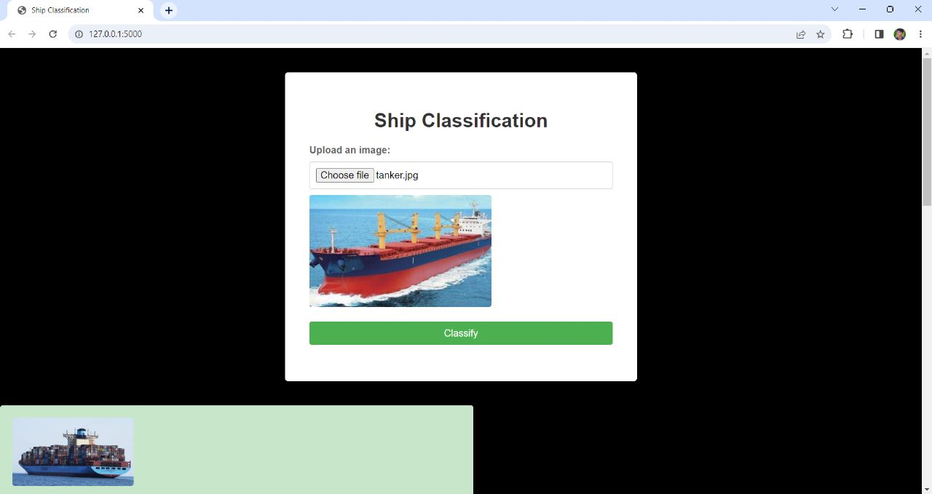

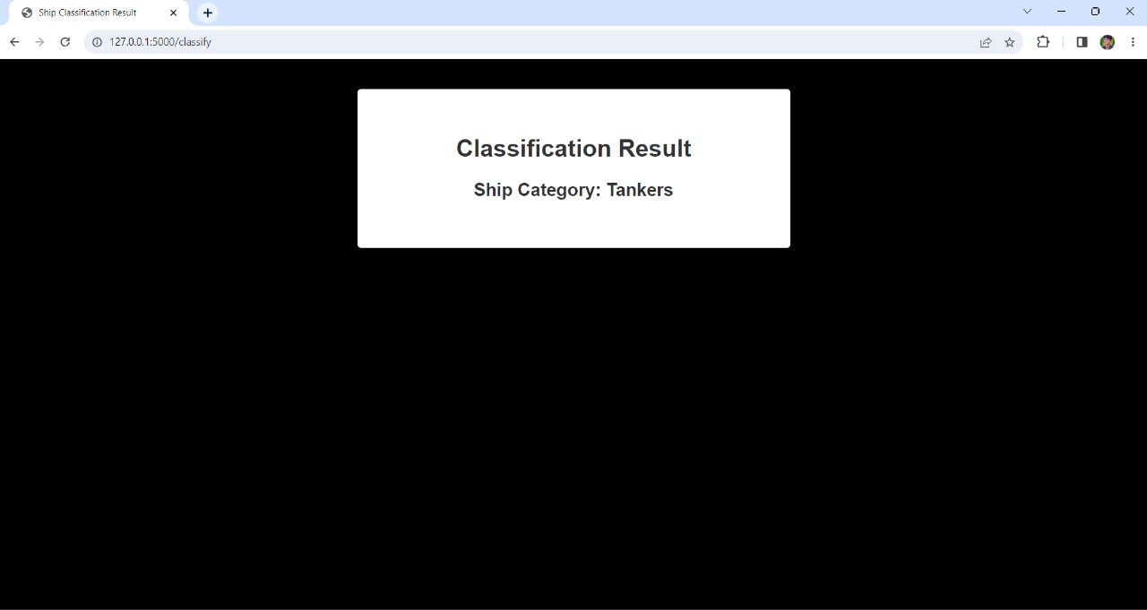

# 

# ADVANTAGES & DISADVANTAGES

Advantages of the proposed solution in ship classification:

1. Accuracy: The proposed solution, when properly trained and evaluated, can achieve high accuracy in ship classification, helping to ensure reliable results.
2. Automation: By employing machine learning or intelligent algorithms, the proposed solution can automate the ship classification process, reducing the need for manual intervention and saving time and effort.
3. Scalability: The solution can handle large amounts of ship data efficiently, making it suitable for classifying a vast number of ships within a reasonable time frame.
4. Adaptability: Machine learning models used in ship classification can adapt and learn from new data, allowing the solution to improve its classification accuracy over time as it encounters new ship instances.
5. Objectivity: The proposed solution can provide objective and consistent classification results, eliminating potential biases or subjective interpretations that may arise from manual classification methods.

Disadvantages of the proposed solution in ship classification:

1. Data Quality: The accuracy and reliability of the ship classification heavily depend on the quality of the input data. Inaccurate or incomplete ship data may lead to erroneous classifications.
2. Data Availability: Acquiring comprehensive ship data, especially for smaller or less documented vessels, can be challenging, potentially limiting the effectiveness of the ship classification solution.
3. Model Complexity: The use of advanced machine learning algorithms or intelligent techniques may introduce complexity to the ship classification solution, requiring specialized knowledge and expertise for development and maintenance.
4. Training and Evaluation: Training a classification model requires a sufficient amount of labeled ship data, and the evaluation process needs careful consideration to select appropriate performance metrics and avoid overfitting or underfitting issues.
5. Interpretability: Some advanced machine learning algorithms used in ship classification, such as deep learning models, may lack interpretability, making it difficult to understand the reasoning behind the classification decisions.

APPLICATIONS

The proposed solution for ship classification can find applications in various areas within the maritime industry. Here are some examples:

1. Maritime Safety: Ship classification plays a crucial role in ensuring maritime safety. By accurately categorizing ships based on their characteristics and performance, the solution can help identify potential risks, assess vessel stability, and determine compliance with safety regulations.
2. Maritime Surveillance: Ship classification can aid in maritime surveillance activities, such as monitoring vessel traffic, identifying suspicious or unauthorized vessels, and supporting maritime law enforcement efforts. The solution can assist in distinguishing between different types of ships, such as cargo vessels, fishing boats, or military vessels.
3. Port Management: Ship classification can be valuable for efficient port management. By classifying ships based on their size, tonnage, and other relevant attributes, the solution can assist in allocating berths, optimizing resource allocation, and facilitating logistics planning within ports.
4. Environmental Monitoring: The solution can contribute to environmental monitoring efforts in the maritime domain. By classifying ships based on their emissions, fuel consumption, or environmental impact, it can support initiatives aimed at reducing pollution, enforcing emission regulations, and promoting sustainable shipping practices.
5. Maritime Insurance: Ship classification can be utilized in the maritime insurance industry. Accurately classifying ships can help insurers assess risks, determine insurance premiums, and evaluate vessel condition, which is crucial for underwriting policies and managing claims related to marine insurance.

conclusion

In conclusion, ship classification is a critical process in the maritime industry that involves categorizing ships based on various characteristics and performance parameters. This classification enables efficient and safe operations, supports decision-making processes, and ensures compliance with regulatory requirements.

Throughout this work, we have explored ship classification from different perspectives, including literature surveys, advantages and disadvantages, and applications of the proposed solution.

The literature surveys provided a comprehensive overview of ship classification methods, including rule-based systems, machine learning techniques, and hybrid approaches. These surveys highlighted the strengths, limitations, and applications of various classification methods, serving as valuable references for further research in this field.

The applications of ship classification span across various areas within the maritime industry. These include maritime safety, surveillance, port management, environmental monitoring, insurance, ship traffic management, and ship design and engineering. The proposed solution can contribute to these areas by providing accurate ship classification results, aiding decision-making processes, and supporting operational efficiency.

Overall, ship classification is a complex and multifaceted process with significant implications for the maritime industry. The proposed solution offers a promising approach to enhance accuracy, automation, and decision support in ship classification, paving the way for improved safety, efficiency, and sustainability in maritime operations. Further research and development in this field can contribute to advancing ship classification methodologies and their practical applications.

FUTURE SCOPE

Certainly! Here are some potential enhancements that can be made in the future for ship classification:

1. Fine-grained Classification: Currently, ship classification typically involves categorizing ships into broad classes or types. Future enhancements can focus on developing more fine-grained classification schemes that capture subtle differences and variations within ship classes. This can enable more precise and detailed classification, leading to improved decision-making and tailored solutions.
2. Multi-label Classification: Ship classification can be extended to handle multi-label classification scenarios, where a ship can belong to multiple categories simultaneously. This can accommodate complex ship configurations or hybrid vessels that possess characteristics of multiple ship types.
3. Incorporation of Contextual Information: Ship classification can be enhanced by considering contextual information, such as the operating environment, route, or purpose of the ship. Contextual factors can influence the classification process and provide additional insights into ship behavior, performance, and compliance.
4. Transfer Learning: Leveraging transfer learning techniques can enhance ship classification by utilizing knowledge learned from related tasks or domains. Pre-trained models or features from other domains, such as object recognition in computer vision, can be adapted and fine-tuned for ship classification, reducing the need for extensive labeled ship data.
5. Ensemble Methods: Ensemble methods, which combine multiple classification models, can be explored to improve the robustness and generalization of ship classification systems. By leveraging the collective knowledge of multiple models, ensemble techniques can help mitigate individual model biases and uncertainties.

BIBILOGRAPHY

REFERENCES:

References used for this project are mentioned below

<https://www.mdpi.com/1424-8220/18/9/2929#:~:text=In%20this%20paper%2C%20convolutional%20neural%20networks%20%28CNNs%29%20are,constructed%20based%20on%20very%20deep%20convolutional%20networks%20%28VGG%29>

<https://ieeexplore.ieee.org/document/8455679>

<https://link.springer.com/article/10.1007/s40747-022-00683-z>

<https://link.springer.com/article/10.1007/s40747-022-00683-z>

<https://ieeexplore.ieee.org/document/8127014>

<https://www.ijert.org/classification-of-ships-using-isar-images-with-combined-deep-transfer-learning-and-gan-processing-framework>

APPENDIX

Source Code:

All the code files are uploaded in the given github repository link

<https://github.com/smartinternz02/SPSGP-523630-Ship-Classification-using-IBM-Watson.git>